ASSIGNMENT 4: HEAP DATA STRUCTURES - IMPLEMENTATION, ANALYSIS, AND APPLICATIONS
Algorithms and Data Structures (MSCS-532-B01)
Dr. Michael Solomon
Nov 8, 2026

ASSIGNMENT 4: HEAP DATA STRUCTURES - IMPLEMENTATION, ANALYSIS, AND APPLICATIONS
INTRODUCTION
This assignment explores heap data structures and their use in sorting and priority scheduling. I implemented Heapsort using an array-based max-heap, then compared its runtime with randomized Quicksort and Merge Sort on several input distributions. I also implemented a max-heap priority queue and used it to simulate a non-preemptive task scheduler.
The benchmark results show that all three sorting algorithms performed reasonably well on the tested inputs. The scheduler results demonstrate how a priority queue selects the highest-priority task among tasks that have arrived.
PART 1: HEAPSORT
Implementation and Design
Heapsort uses a binary max-heap represented by a Python list. In a max-heap, each parent is greater than or equal to its children, so the largest value is stored at the root.
For an array index i, the left child is at index 2i + 1, and the right child is at index 2i + 2. This array representation is compact and avoids the extra memory and pointer management required by a node-based tree.
The implementation first builds a max-heap from the input array. It then repeatedly swaps the root, which contains the largest remaining value, with the last value in the active heap. The active heap is reduced by one element, and the heap property is restored by moving the new root down to its correct position.
Heapsort Complexity Analysis
Building a max-heap takes O(n) time. Although restoring the heap property can take O(log n) for one node, most nodes are near the bottom of the heap and require little work. The total work to build the heap is therefore O(n).
After the heap is built, Heapsort performs n − 1 extraction steps. Each step restores the heap property in O(log n) time. These steps take O(n log n) time in total. Therefore, the overall running time is O(n log n).
This bound applies in the best, average, and worst cases. Heapsort must build the heap and then perform the extraction steps regardless of the original input order. The actual runtime can vary with the input, but its asymptotic time complexity remains O(n log n) in all cases.
Heapsort sorts the input in place and uses O(1) auxiliary space, excluding the input list. Its heap operations do not require allocating another array proportional to the input size.
PART 2: SORTING ALGORITHM COMPARISON
Benchmark Method
I compared Heapsort, randomized Quicksort, and Merge Sort using input sizes of 100, 500, 1,000, 2,000, and 5,000. The tested input distributions were random values, sorted values, reverse-sorted values, and repeated values.
Each timing is the median of three runs, measured in milliseconds. The time to make the input copy for a benchmark run was excluded. Algorithm-specific work, such as Merge Sort’s auxiliary storage, was included.

Benchmark Results
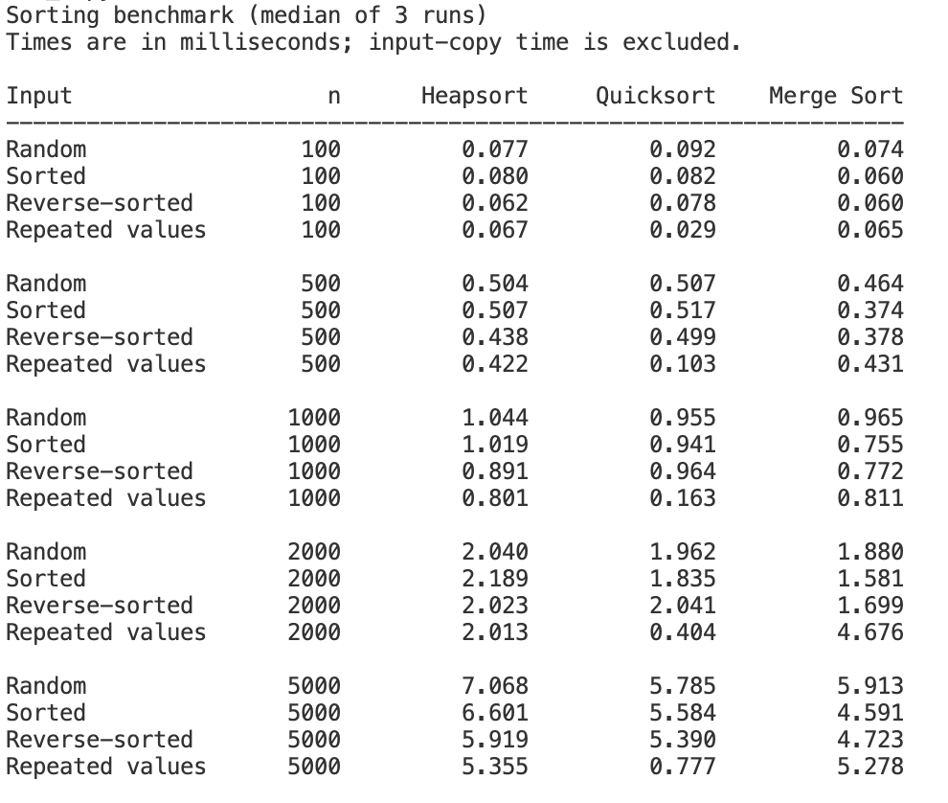
Benchmark Discussion
On random input, the three algorithms had similar runtimes. At an input size of 5,000, Quicksort was fastest at 5.785 ms, followed closely by Merge Sort at 5.913 ms. Heapsort took 7.068 ms. These results are consistent with the algorithms’ expected O(n log n) performance on these inputs, although implementation details and Python runtime overhead affect the measured times.
Heapsort’s times were relatively consistent across sorted, reverse-sorted, and random inputs. This matches its O(n log n) time complexity in all cases: its performance does not depend on the input already being in a favorable order.
Randomized Quicksort also performed consistently across random, sorted, and reverse-sorted inputs in this benchmark. Its pivot is selected randomly, which makes consistently unbalanced partitions less likely. The version used in this program also uses three-way partitioning, which groups values equal to the pivot.
Quicksort was substantially faster on repeated-value inputs. At n = 5,000, it took 0.777 ms, compared with 5.355 ms for Heapsort and 5.278 ms for Merge Sort. Three-way partitioning can finish processing groups of equal values without sorting those values against one another repeatedly.
Merge Sort was fastest on sorted, reverse-sorted, and random inputs at several tested sizes. The higher Merge Sort result for repeated values at n = 2,000 was 4.676 ms, compared with 0.811 ms at n = 1,000 and 5.278 ms at n = 5,000. This isolated result does not follow a smooth growth pattern and may reflect timing variability or system activity during that run. Repeating the benchmark may produce a different value.
These measurements describe one run environment and are not universal guarantees. Small differences can result from processor load, Python overhead, memory allocation, and other system activity. The asymptotic analysis describes how the algorithms scale as input size grows; a benchmark measures one implementation on one computer.

PART 3: PRIORITY QUEUE IMPLEMENTATION
Data Structure and Scheduling Choice
The priority queue is implemented as an array-based max-heap. This representation makes the heap compact and allows parent and child positions to be calculated from array indices. It also supports efficient insertion and removal without shifting all elements.
The scheduler treats a larger numeric priority as more important. When two tasks have the same priority, the task with the earlier arrival time is selected first. If those values are also equal, the task ID provides a consistent tie-breaker.
Each Task object stores a task ID, priority, arrival time, deadline, and duration. The priority queue also maintains a dictionary that maps task IDs to their current heap positions. This allows the queue to find a task efficiently when its priority needs to change.
Priority Queue Operations and Complexity
The insert operation adds a task at the end of the array and moves it upward until the max-heap property is restored. Its time complexity is O(log n).
The extract_max operation removes and returns the root task. It moves the last task to the root and moves it downward until the heap property is restored. Its time complexity is O(log n).
The increase_key operation raises a task’s priority and moves the task upward as needed. The decrease_key operation lowers its priority and moves it downward as needed. The dictionary locates the task in O(1) expected time, and restoring the heap property takes O(log n), so each priority update takes O(log n).
The is_empty operation checks whether the heap contains any tasks. It takes O(1) time.
Scheduler Simulation and Results
The simulation uses a non-preemptive scheduling policy. When a task starts running, it continues until its duration is complete. At each available scheduling point, the scheduler selects the highest-priority task among those that have arrived. If no task is ready, the simulated time advances to the next task’s arrival time.
The scheduler produced this execution order:
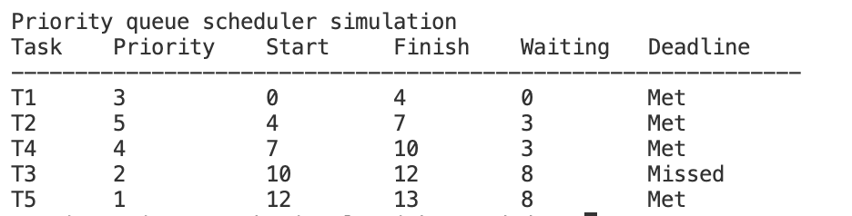
T1 starts immediately because it is the only task that has arrived at time 0. While T1 runs, T2, T3, T4, and T5 arrive. When T1 finishes, the scheduler selects T2, which has the highest priority among the ready tasks. The remaining tasks are then selected in descending priority order.
T3 is the only task that misses its deadline. It finishes at time 12, after its deadline of time 10. The total waiting time is 22 time units, and the average waiting time is 4.4 time units per task.

CONCLUSION
The benchmark showed that Heapsort maintained consistent performance across the tested input distributions, in line with its O(n log n) best-, average-, and worst-case time complexity. Merge Sort performed well on most test cases, while randomized Quicksort was especially fast on arrays with repeated values because of its three-way partitioning.
The priority queue used a max-heap to select the highest-priority available task. Its insert, extract_max, increase_key, and decrease_key operations take O(log n), while checking whether it is empty takes O(1). The scheduler simulation demonstrated how task priority, arrival time, and deadlines affect execution order and waiting time.

